**Windows 10 UWP – Hands on Lab**

**Lab 4:**

**Note**: This demo app created for this lab uses the Visual Studio 2015 RTM and Windows Tools SDK ver 10240.

1. Open the \Views\MainPage.xaml file and add the following lines of xaml code to line 14.

<VisualStateManager.VisualStateGroups>

<VisualStateGroup x:Name="WindowStates">

<VisualState x:Name="NarrowState">

<VisualState.StateTriggers>

<AdaptiveTrigger MinWindowWidth="1"/>

</VisualState.StateTriggers>

<VisualState.Setters>

<Setter Target="RecipesGridView.Visibility" Value="Collapsed" />

<Setter Target="RecipesListView.Visibility" Value="Visible" />

</VisualState.Setters>

</VisualState>

<VisualState x:Name="WideState">

<VisualState.StateTriggers>

<AdaptiveTrigger MinWindowWidth="1000"/>

</VisualState.StateTriggers>

<VisualState.Setters>

<Setter Target="RecipesGridView.Visibility" Value="Visible" />

<Setter Target="RecipesListView.Visibility" Value="Collapsed" />

</VisualState.Setters>

</VisualState>

<VisualState x:Name="MediumState">

<VisualState.StateTriggers>

<AdaptiveTrigger MinWindowWidth="660"/>

</VisualState.StateTriggers>

<VisualState.Setters>

<Setter Target="RecipesGridView.Visibility" Value="Collapsed" />

<Setter Target="RecipesListView.Visibility" Value="Visible" />

</VisualState.Setters>

</VisualState>

</VisualStateGroup>

</VisualStateManager.VisualStateGroups>

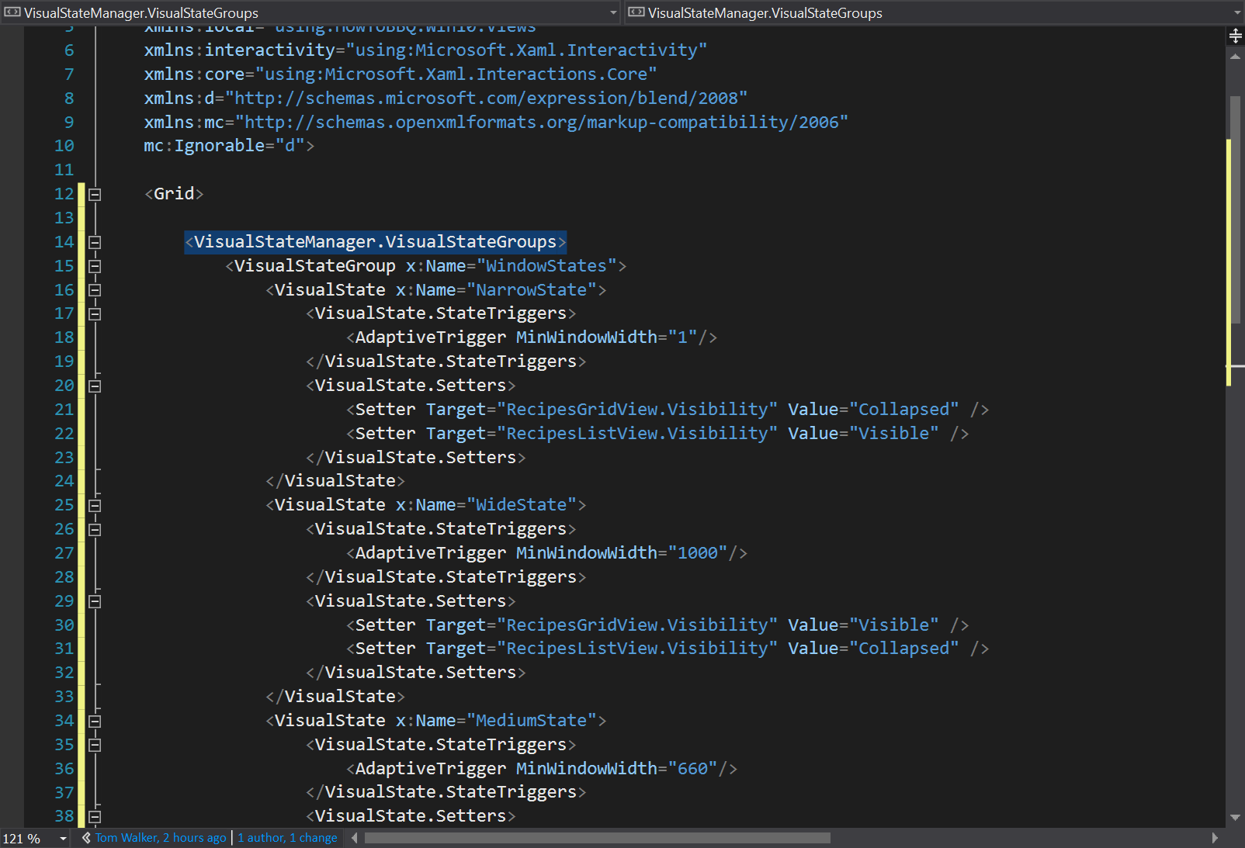

1. In the \Views\MainPage.xaml file and add the following lines of xaml code to line 72.

<ListView x:Name="RecipesListView"

ItemsSource="{Binding Recipes}"

SelectionMode="Single"

IsItemClickEnabled="True"

Margin="40,20,30,0"

HorizontalAlignment="Left"

VerticalAlignment="Center"

Visibility="Collapsed">

<interactivity:Interaction.Behaviors>

<core:EventTriggerBehavior EventName="ItemClick">

<core:CallMethodAction MethodName="BBQRecipeTapped"

TargetObject="{Binding Mode=OneWay}" />

</core:EventTriggerBehavior>

</interactivity:Interaction.Behaviors>

<ListView.ItemContainerStyle>

<Style TargetType="ListViewItem">

<Setter Property="Height" Value="Auto"/>

<Setter Property="Margin" Value="20"/>

</Style>

</ListView.ItemContainerStyle>

<ListView.ItemTemplate>

<DataTemplate>

<Grid>

<Image Source="{Binding ImageSource}"/>

<Border Background="#99000000" VerticalAlignment="Bottom">

<TextBlock Grid.Column="1" Text="{Binding Name}"

FontSize="15" Margin="10" VerticalAlignment="Center"/>

</Border>

</Grid>

</DataTemplate>

</ListView.ItemTemplate>

</ListView>

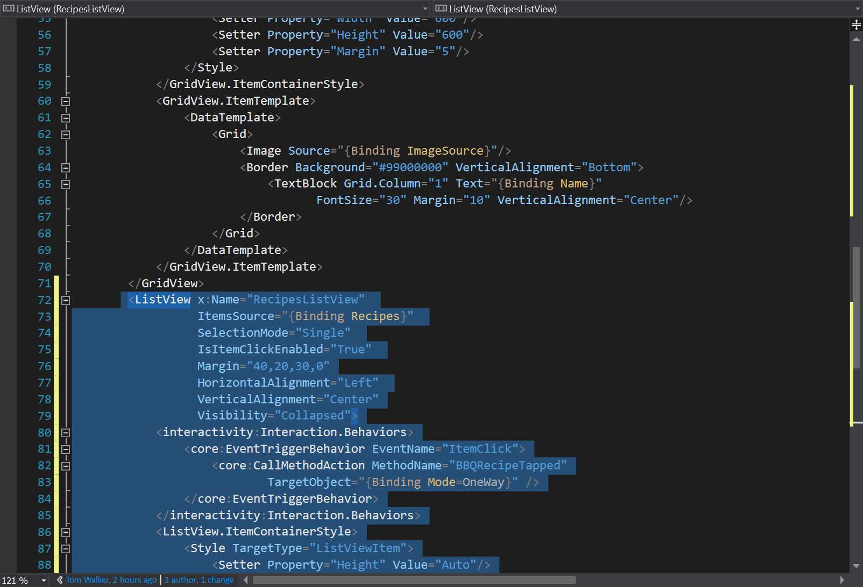

1. Open the \Views\BBQRecipePage.xaml file and add the following lines of xaml code to line 11

<VisualStateManager.VisualStateGroups>

<VisualStateGroup x:Name="WindowStates">

<VisualState x:Name="NarrowState">

<VisualState.StateTriggers>

<AdaptiveTrigger MinWindowWidth="1"/>

</VisualState.StateTriggers>

<VisualState.Setters>

<Setter Target="BBQImage.Height" Value="300" />

<Setter Target="BBQImage.Width" Value="300" />

<Setter Target="PageTitle.Style" Value="{StaticResource

SubtitleTextBlockStyle}" />

<Setter Target="DetailstackPanel.(RelativePanel.Below)"

Value="ImageStackPanel" />

<Setter Target="DetailstackPanel.Margin" Value="0,0,0,0"/>

</VisualState.Setters>

</VisualState>

<VisualState x:Name="WideState">

<VisualState.StateTriggers>

<AdaptiveTrigger MinWindowWidth="1000"/>

</VisualState.StateTriggers>

<VisualState.Setters>

<Setter Target="BBQImage.Height" Value="600" />

<Setter Target="BBQImage.Width" Value="600" />

<Setter Target="PageTitle.Style" Value="{StaticResource

HeaderTextBlockStyle}" />

<Setter Target="DetailstackPanel.(RelativePanel.RightOf)"

Value="ImageStackPanel"/>

<Setter

Target="DetailstackPanel.(RelativePanel.AlignBottomWith)" Value="ImageStackPanel" />

<Setter Target="DetailstackPanel.Margin" Value="50,0,0,0"/>

</VisualState.Setters>

</VisualState>

<VisualState x:Name="MediumState">

<VisualState.StateTriggers>

<AdaptiveTrigger MinWindowWidth="660"/>

</VisualState.StateTriggers>

<VisualState.Setters>

<Setter Target="BBQImage.Height" Value="300" />

<Setter Target="BBQImage.Width" Value="300" />

<Setter Target="PageTitle.Style" Value="{StaticResource SubtitleTextBlockStyle}" />

<Setter Target="DetailstackPanel.(RelativePanel.Below)" Value="ImageStackPanel" />

<Setter Target="DetailstackPanel.Margin" Value="0,0,0,0"/>

</VisualState.Setters>

</VisualState>

</VisualStateGroup>

</VisualStateManager.VisualStateGroups>

<Grid.RowDefinitions>

<RowDefinition Height="140"/>

<RowDefinition Height="*"/>

</Grid.RowDefinitions>

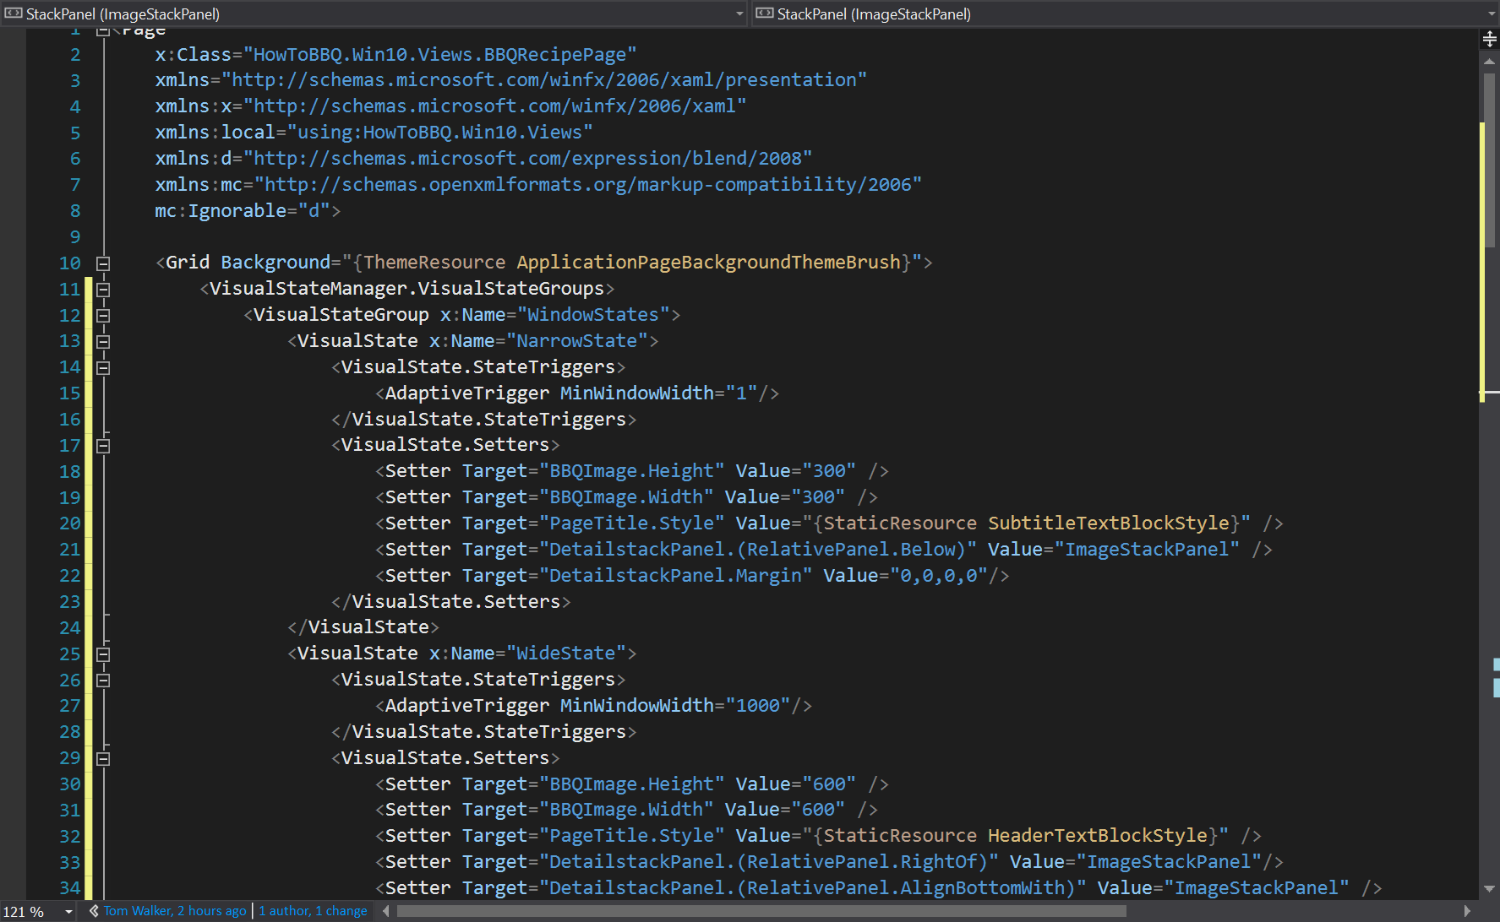

1. In the \Views\BBQRecipePage.xaml file and add the following lines of xaml code to line 59

<ScrollViewer>

<RelativePanel>

<StackPanel x:Name="ImageStackPanel" Orientation="Vertical"

HorizontalAlignment="Left">

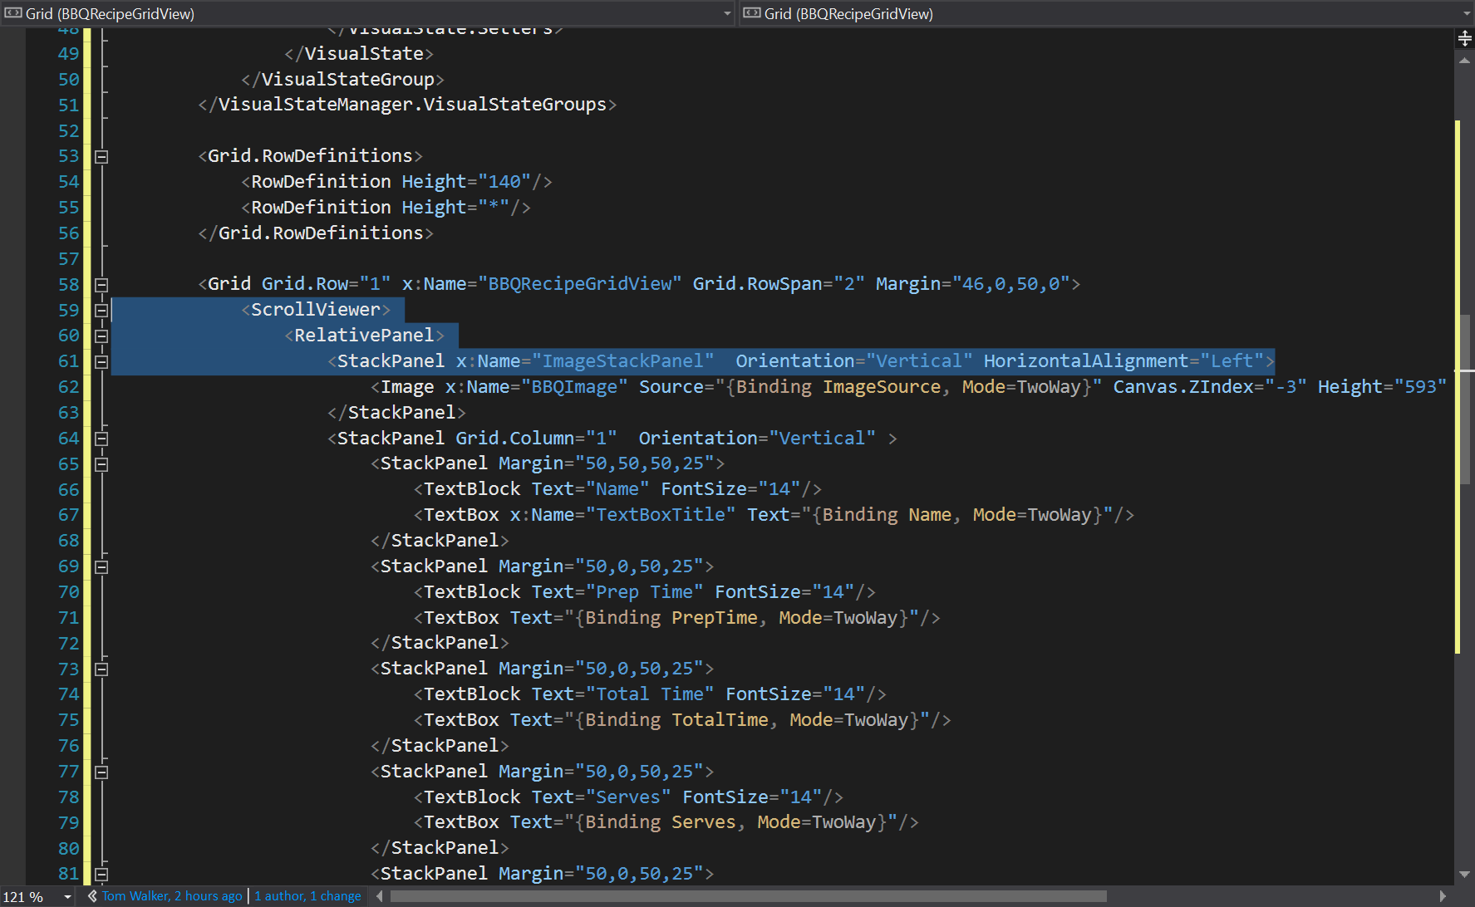

1. In the \Views\BBQRecipePage.xaml file and add the following lines of xaml code to line 112

</RelativePanel>

</ScrollViewer>

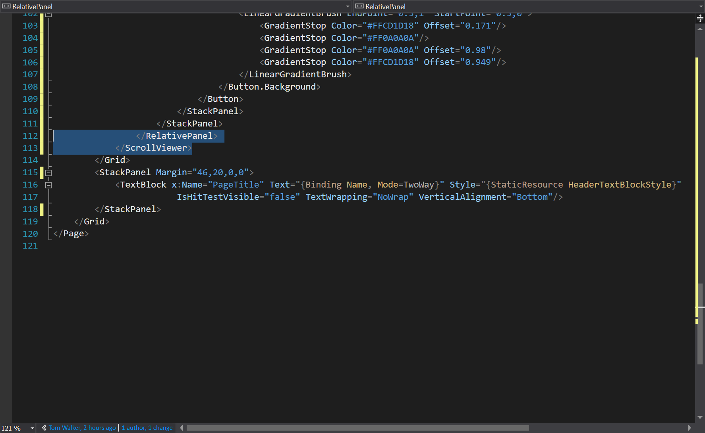

1. In the \Views\BBQRecipePage.xaml file and update the following lines of xaml code to line 155. Remove the “Grid.ColumnSpan="2"” attribute.

<StackPanel Margin="46,20,0,0">

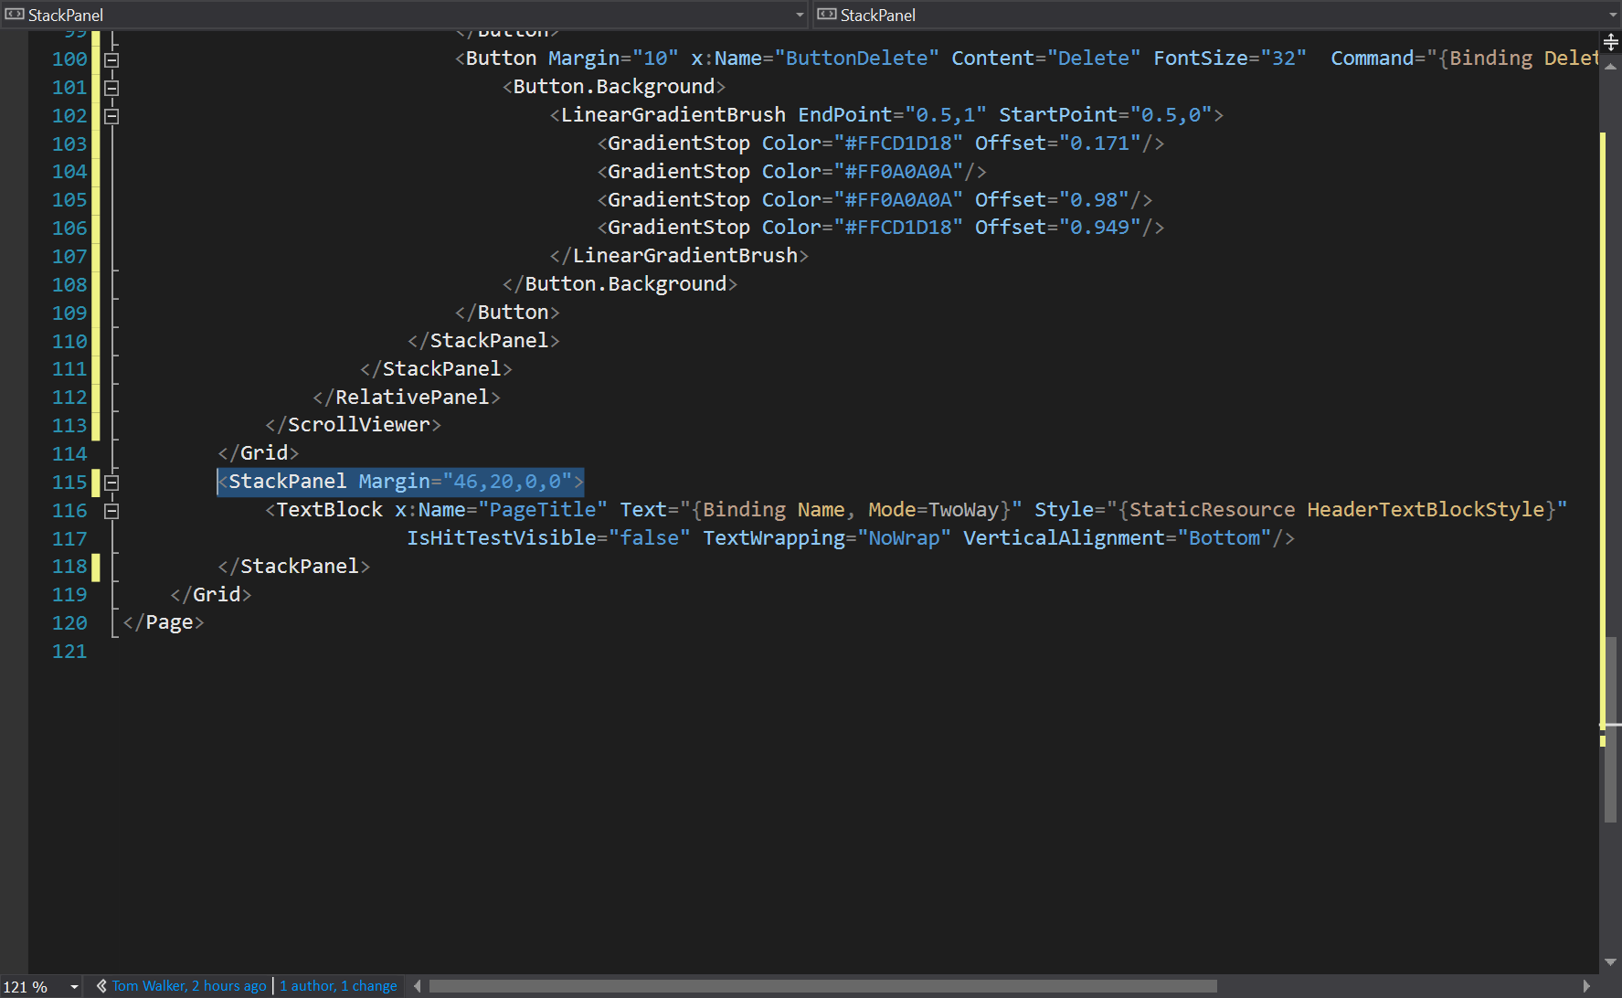

1. In the \Views\BBQRecipePage.xaml file and update the following lines of xaml code to line starting on 64. This step is updating the contents of the StackPanel.

<StackPanel x:Name="DetailstackPanel" Orientation="Vertical" HorizontalAlignment="Left">

<StackPanel Margin="0,20,20,10">

<TextBlock Text="Name" FontSize="14"/>

<TextBox x:Name="TextBoxTitle" Text="{Binding Name,

Mode=TwoWay}"/>

</StackPanel>

<StackPanel Margin="0,0,20,10">

<TextBlock Text="Prep Time" FontSize="14"/>

<TextBox Text="{Binding PrepTime, Mode=TwoWay}"/>

</StackPanel>

<StackPanel Margin="0,0,20,10">

<TextBlock Text="Total Time" FontSize="14"/>

<TextBox Text="{Binding TotalTime, Mode=TwoWay}"/>

</StackPanel>

<StackPanel Margin="0,0,20,10">

<TextBlock Text="Serves" FontSize="14"/>

<TextBox Text="{Binding Serves, Mode=TwoWay}"/>

</StackPanel>

<StackPanel Margin="0,0,20,10">

<TextBlock Text="Ingredients" FontSize="14"/>

<TextBox Text="{Binding Ingredients, Mode=TwoWay}"/>

</StackPanel>

<StackPanel Margin="0,0,20,10">

<TextBlock Text="Directions" FontSize="14"/>

<TextBox Text="{Binding Directions, Mode=TwoWay}"

Height="150" TextWrapping="Wrap"/>

</StackPanel>

<StackPanel Margin="0,0,20,10" Orientation="Horizontal"

Padding="10" HorizontalAlignment="Center">

<Button Margin="10" x:Name="ButtonSave" Content="Save"

FontSize="32" Command="{Binding SaveCommand}">

<Button.Background>

<LinearGradientBrush EndPoint="0.5,1"

StartPoint="0.5,0">

<GradientStop Color="#FF6ACD18" Offset="0.171"/>

<GradientStop Color="#FF0A0A0A"/>

<GradientStop Color="#FF0A0A0A" Offset="0.98"/>

<GradientStop Color="#FF6ACD18" Offset="0.949"/>

</LinearGradientBrush>

</Button.Background>

</Button>

<Button Margin="10" x:Name="ButtonDelete" Content="Delete"

FontSize="32" Command="{Binding DeleteCommand}">

<Button.Background>

<LinearGradientBrush EndPoint="0.5,1"

StartPoint="0.5,0">

<GradientStop Color="#FFCD1D18" Offset="0.171"/>

<GradientStop Color="#FF0A0A0A"/>

<GradientStop Color="#FF0A0A0A" Offset="0.98"/>

<GradientStop Color="#FFCD1D18" Offset="0.949"/>

</LinearGradientBrush>

</Button.Background>

</Button>

<Button Margin="10" x:Name="ButtonShare" Content="Share"

FontSize="32" Command="{Binding ShareCommand}">

<Button.Background>

<LinearGradientBrush EndPoint="0.5,1"

StartPoint="0.5,0">

<GradientStop Color="#FFC681F2" Offset="0.171"/>

<GradientStop Color="#FF0A0A0A"/>

<GradientStop Color="#FF0A0A0A" Offset="0.98"/>

<GradientStop Color="#FFC681F2" Offset="0.949"/>

</LinearGradientBrush>

</Button.Background>

</Button>

</StackPanel>

</StackPanel>

